Task Management Web Application

Course: UI/UX Design Fundamentals

Institution: Christ University

Group Members:

* Sricharan A - 2462532
* Swara Madichedi - 2462533
* Anirudh V O - 2462536

**1. Project Overview**

The To-Do List Application is a simple, browser-based task management tool designed to help users organize their daily activities. Built using HTML, CSS (Bootstrap 5), JavaScript, and jQuery, the application provides an intuitive interface for adding, editing, deleting, and categorizing tasks.

The application’s key strength is its use of the localStorage API, which ensures that tasks remain saved even after refreshing or closing the browser. Users can filter their tasks into All, Active, and Completed categories, making it easier to track progress. A modal-based edit feature further enhances usability by allowing tasks to be updated without cluttering the main interface.

With features like a dynamic task counter, clear completed button, and hover effects for better UI experience, the application provides a clean and efficient platform for personal productivity. While currently limited to local storage, the project lays a strong foundation for future enhancements such as cloud sync, reminders, and priority settings.

In summary, this project demonstrates how front-end technologies can be combined to create a responsive, interactive, and user-friendly task management system.

**2. Objectives**

* To design a simple and user-friendly interface for managing daily tasks.
* To enable users to add, edit, delete, and mark tasks as completed.
* To provide task filtering options (All, Active, Completed) for better organization.
* To implement data persistence using the browser’s localStorage so that tasks remain saved across sessions.
* To create a responsive layout using Bootstrap, making the application accessible on different devices.
* To ensure efficient task tracking through a dynamic task counter and clear completed option.

3. Expected Outcomes

* A fully functional web-based To-Do List Application that allows users to add, edit, delete, and manage tasks.
* A responsive and clean user interface built with Bootstrap for ease of use across devices.
* Task categorization and filtering (All, Active, Completed) for better productivity.
* Persistence of tasks using local Storage so that data is retained even after refreshing or closing the browser.
* Improved time management and organization for users by providing a simple digital task manager.
* A foundation for future enhancements, such as reminders, priority levels, and cloud-based storage.

**4. Pages & Design**

1) Home Page (Main Application Page)

* Header: Displays the title *“To-Do List”*.
* Task Input Section:
  + A text box to enter a new task.
  + An “Add” button to insert the task into the list.
* Filter Buttons:
  + Options for All, Active, Completed tasks.
  + Highlighted state for the active filter.
* Task List Area:
  + Tasks displayed in a list with a checkbox, title, edit, and delete buttons.
  + Completed tasks appear with a strike-through style.
* Task Counter & Clear Completed:
  + Shows total number of tasks.
  + Option to clear all completed tasks.

2)Edit Task Modal

* A Bootstrap modal popup for editing existing tasks.
* Contains a text box to update the task title.
* Buttons for Save and Cancel actions.

**Design Highlights**

* Color Scheme: Light background (#f8f9fa) with Bootstrap’s default theme for buttons.
* Typography: Clean, readable text styled with Bootstrap classes.
* Hover Effects: Task items slightly change background color on hover.
* Responsiveness: Layout adapts to different screen sizes (desktop, tablet, mobile).
* User Experience:
  + Double-click or click “Edit” to modify tasks.
  + Smooth interactions using jQuery and Bootstrap transitions.

.

5. Design Choices

• Font: Inter (Google Fonts) for modern readability.

• Color Palette: Teal accent with muted greys for text.

• Layout: CSS Grid for page composition, Flexbox used inside components.

• Accessibility: semantic tags, skip-link, proper alt text.

• Responsiveness: media queries for breakpoints at 900px and 520px.

**6. Technical Implementation**

* Built using HTML5, CSS (Bootstrap 5), JavaScript, and jQuery.
* Tasks stored as objects with ID, title, and status (active/completed).
* LocalStorage used for persistence across sessions.
* Add Task: Input + Add button saves to list and localStorage.
* Edit Task: Bootstrap modal updates task title in UI and storage.
* Delete Task: Removes task from list and localStorage.
* Complete Task: Checkbox toggles status, applies line-through style.
* Filter Options: Show All, Active, or Completed tasks using jQuery.
* Clear Completed: Removes all completed tasks at once.
* UI Features: Responsive layout, hover effects, dynamic task counter.

7. Sample Code Snippets

$('#task-form').on('submit', function(e){

e.preventDefault();

tasks.push({ id: Date.now(), title: $('#task-input').val(), completed: false });

saveTasks(); renderTasks();

$('#task-input').val('');

});

$('#save-edit').on('click', function(){

tasks.forEach(t => { if (t.id === editTaskId) t.title = $('#edit-input').val(); });

saveTasks(); renderTasks();

bootstrap.Modal.getInstance($('#editModal')).hide();

});

let deleteBtn = $('<button>Delete</button>').on('click', function(){

tasks = tasks.filter(t => t.id !== task.id);

saveTasks(); renderTasks();

});

**8. Screenshots**

1. Home Page

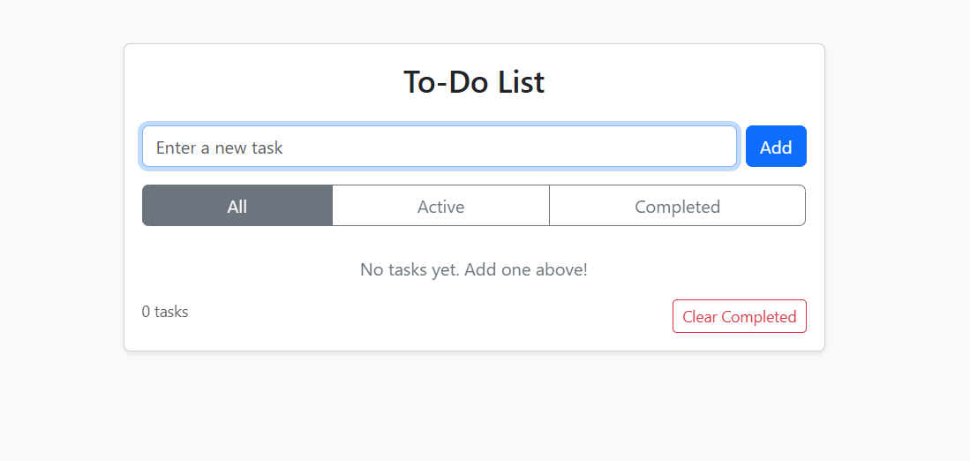

1. Task list display

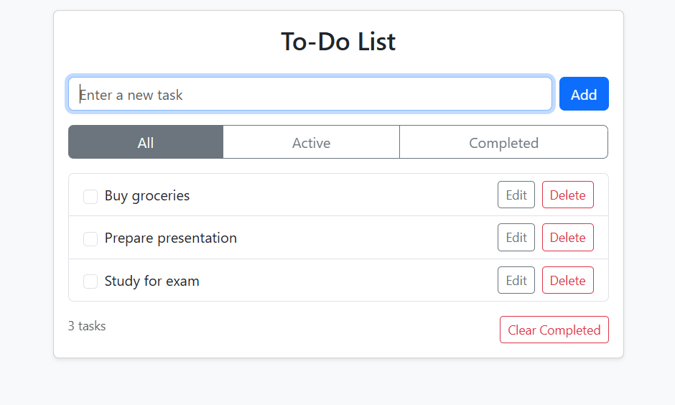

1. Mark as completed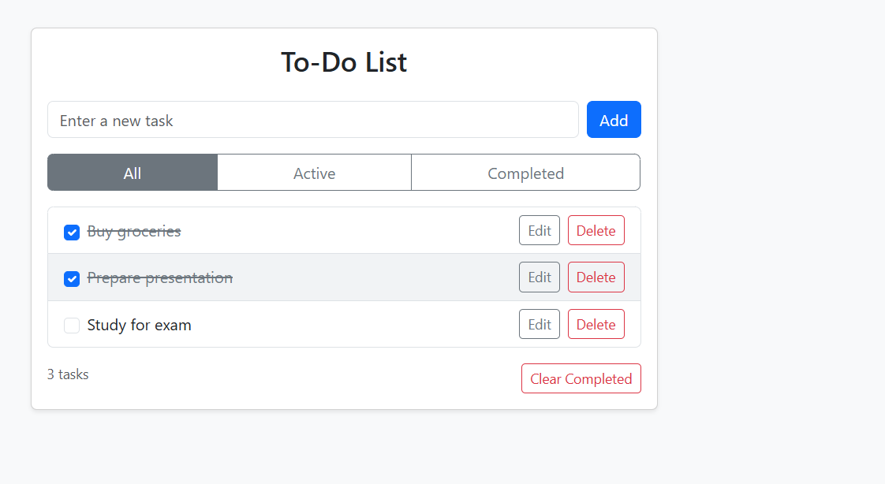
2. Edit task modal

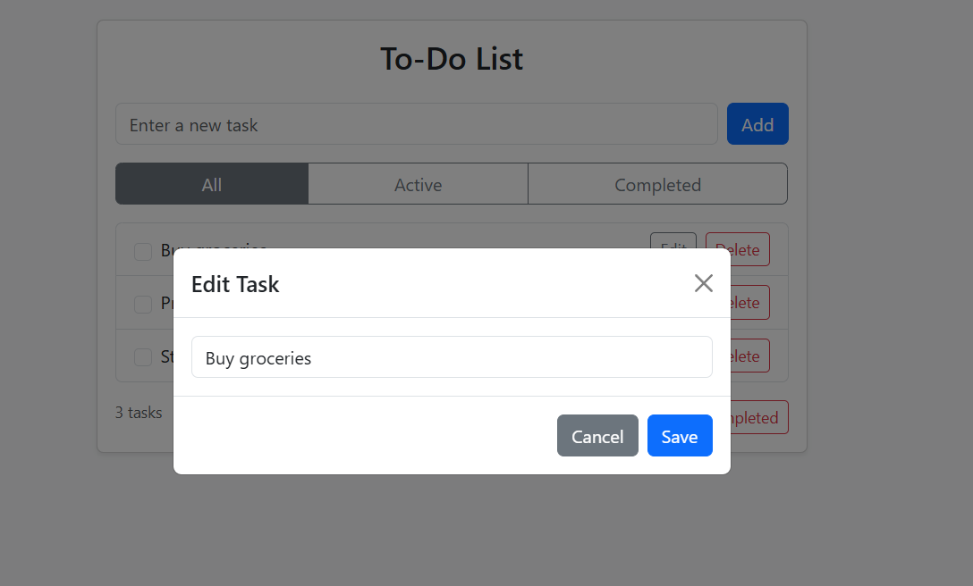

1. Filter Completed Tasks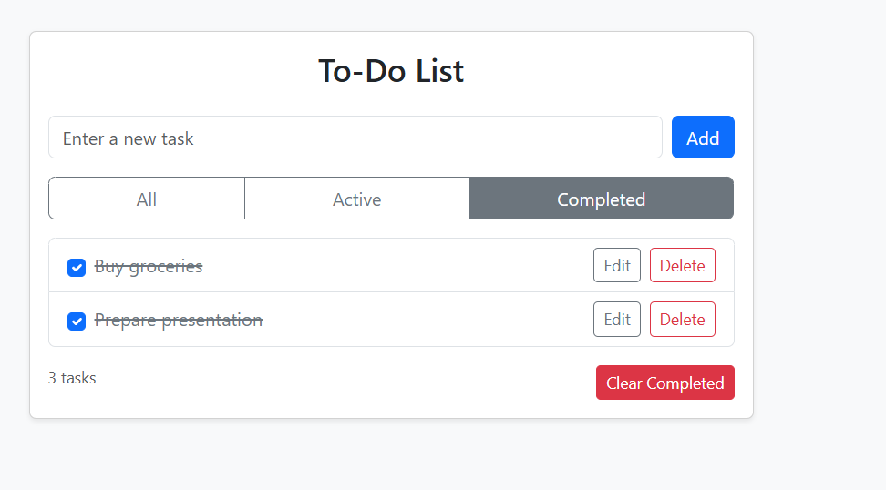

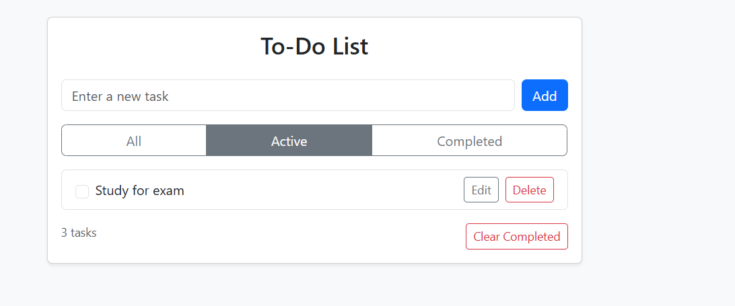

Clear completed

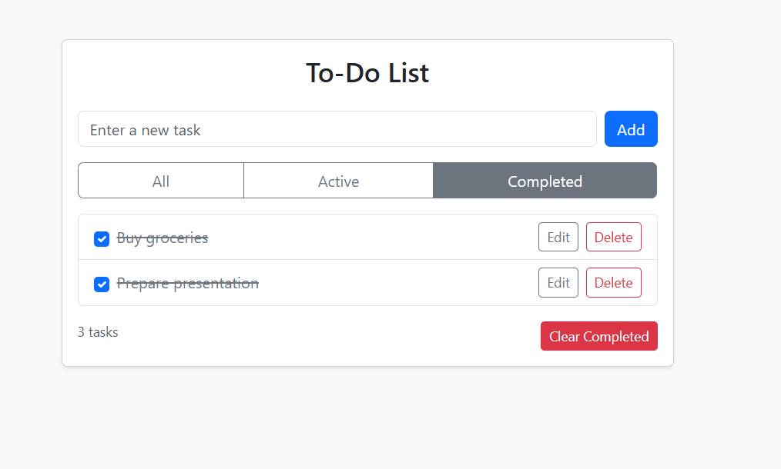

**9. Group Roles & Contribution**

* **Swara**: Designed the UI layout using HTML and Bootstrap, ensuring responsiveness.
* **Sri Charan**: Implemented the core functionality (Add, Edit, Delete, Complete tasks) using JavaScript/jQuery.
* **Anirudh**: Integrated localStorage for task persistence, crea

**10. GitHub & Submission**

Repository: https://github.com/sricharan-abtech/Front-End-UI-UX-Webpage-Design-CIA3

**11. Final Checklist**

• Pages implemented: index, about, projects, contact

• Semantic HTML used

• CSS responsive design

• Project report attached in repository

• GitHub repository public and linked in spreadsheet

Sricharan A - 2462532 - sricharan.a@btech.christuniversity.in

Swara Madichedi - 2462533 - swara.madichedi@btech.christuniversity.in

Anirudh VO - 2462536 - vo.anirudh@btech.christuniversity.in